**EVs Charging Technology**

***Charging stations are not just AC-to-DC transformer but also communication centers between smart electricity grid and smart cars with high capacity batteries.***

An electric charging station cannot be seen as just an element in an infrastructure that supplies electric energy for the recharging of electric vehicles by simply transforming electricity from AC to DC voltage. Conventional perception of charging station is rapidly advancing with technological innovations on electric grid and EVs battery technology. EVs are becoming smart cars with Internet of Things (IoT) and electric grids becoming smart grids. EVs charging stations are also becoming a significant elements that enable communication between these two advanced product and service environments that evolves beyond our imagination and too fast.

**Context**

Charging stations fall into 4 basic concepts: residential charging that is the most common charging method, charging while parked that is a commercial venture charged or free, offered in partnership with the owners of the parking lot, fast charging that supplies higher than 40 kW, delivering over 60miles (100 km) of range in 10–30 minutes and battery swaps that enable to change battery under 15 minutes. There are four different modes of charging defined by the International Electrotechnical Commission (IEC 62196). Plug types can also grouped in four types.

**Charging times and fast Charging**

Charging time is dependent on reachable phase of electric grid and battery capacity of the EVs. Yet new technological innovations comes out very quickly and provides shorter times. At present, different EVs are on the market that provide different battery capacity about 20kWh (Nissan) or 85 kWh (Tesla Motors).

DC fast chargers – also called hyper charger– has scale from 250 KW to 1MW and those has the highest energy density in its class. Fast chargers are designed to provide fleets of any sizes, in general mass transit vehicles. This makes DC fast chargers more efficient and practical for governments and companies.

|  |  |  |  |
| --- | --- | --- | --- |
| **Charging time for 100 km** | **Power supply** | **Voltage** | **Max current** |
| **6–8 hours** | Single phase - 3.3 kW | 230 VAC | 16 A |
| **3–4 hours** | [Single phase - 7 kW](http://en.wikipedia.org/wiki/Single_phase) | 230 VAC | 32 A |
| **2–3 hours** | [Three phase - 10 kW](http://en.wikipedia.org/wiki/Three_phase) | 400 VAC | 16 A |
| **1–2 hours** | [Three phase - 22 kW](http://en.wikipedia.org/wiki/Three_phase) | 400 VAC | 32 A |
| **20–30 minutes** | [Three phase - 43 kW](http://en.wikipedia.org/wiki/Three_phase) | 400 VAC | 63 A |
| **20–30 minutes** | [Direct current - 50 kW](http://en.wikipedia.org/wiki/Direct_current) | 400 - 500 VDC | 100 - 125 A |
| **10 minutes** | [Direct current - 120 kW](http://en.wikipedia.org/wiki/Direct_current) | 300 - 500 VDC | 300 - 350 A |

**Battery swapping**

For this technology first the EV must be designed for "easy swap" of batteries such as Better Place, Tesla Motors, and Mitsubishi Heavy Industries. Some companies use different battery switching technology to extent EVs driving range. The driver does not own the battery in the car, transferring costs over the battery, battery life, maintenance, capital cost, quality, technology, and warranty to the battery switch station company. Moreover, for battery swapping system, ownership of the battery belongs to company of swapping station and this enables decrease in cost of EVs manufacturing up to %45. Swapping stations also give hope to establish more advanced connection with smart grid system and being partner of more sustainable energy system in a profitable case. However, electric vehicle manufacturers that are working on battery switch technology have not standardized on battery access, attachment, dimension, location, or type.

**Wireless Power Transfer**

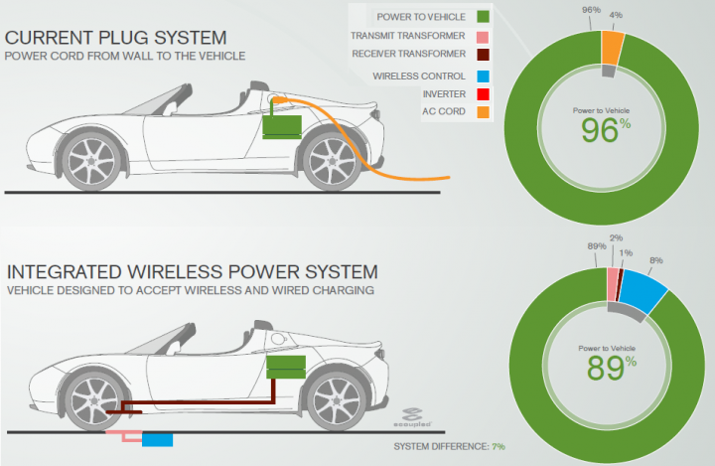With increased coil distances, reduced electromagnetic inference risks and more compact geometrical dimensions in wireless charging (also known inductive charging) systems following the principle of inductive resonant energy transfer can achieve the best energy transfer rates and efficiency rates. Wireless charging offers many advantages at present and some products have already started to be manufactured. Using wireless charging system for known routes such as bus stations and possibility of in-motion charging technology are promising areas for the future of this technology.

**Smart grid communication**

Recharging a large battery pack presents a high load on the electrical grid, but this can be scheduled for periods of reduced load or reduced electricity costs. In order to schedule the recharging, either the charging station or the vehicle can communicate with the [smart grid](http://en.wikipedia.org/wiki/Smart_grid). Some EVs allow the vehicle operator to control recharging through a web interface or smartphone app. Furthermore, in a [Vehicle-to-grid](http://en.wikipedia.org/wiki/Vehicle-to-grid) scenario the vehicle battery can supply energy to the grid at periods of peak demand.

**Software**

Mobile smart phone applications are becoming a standard feature of electric cars and EV charging. Multiple competing apps are available to find charging stations, monitor charging, activate public chargers, and share access to private chargers—and to perform a host of remote functions for the vehicle itself. With smart grid technology and the effect of Internet of Things on EVs, future of charging stations seems to make advanced software needs inevitable.

<http://www.andromedapower.com/>

<http://www.evtronic.com/page7/page9/index.html>

<http://www.eaton.com/Eaton/ProductsServices/Electrical/Markets/AlternativeEnergy/ElectricVehicle/index.htm?wtredirect=www.eaton.com/plugin#tabs-2>

**Electric vehicle hyper charger**

<http://www.eesi.org/briefings/view/16th-annual-congressional-renewable-energy-and-energy-efficiency-expo-forum?/expo2013>

<http://www.plugincars.com/tesla-motors-introduces-free-app-model-s-sedan-126356.html>

**Wireless Power Transfer**

[**http://electricvehicle.ieee.org/2014/06/26/overview-wireless-charging-electrified-vehicles-basic-principles-challenges/**](http://electricvehicle.ieee.org/2014/06/26/overview-wireless-charging-electrified-vehicles-basic-principles-challenges/)

[**https://pluglesspower.com/**](https://pluglesspower.com/)

<https://www.youtube.com/watch?v=Gw6XtzEOlyI> (Wifi, active caharging)

<https://www.youtube.com/watch?v=h6jKvZgkSFE>

**EV Battery Technology**

<http://www.eenews.net/stories/1059984950>